**GOVERNMENT ARTS COLLEGE, DHARMAPURI-636705.**

**DEPARTMENT OF ELECTRONICS & COMMUNICAION**

**AFFILIATED TO PERIYAR UNIVERSITY**

**2023-2024**



**PROJECT COMPLETION REPORT**

PROJECT TITLE

SUBSCRIBERS GALORE:

EXPLORING WORLD’S TOP YOUTUBE CHANNEL.

SUBMITTED BY:

1. ARUNKUMAR R C21UG105ELC005

2 . DHANUSH V C21UG105ELC006

3 . JAYAKUMAR K C21UG105ELC010

4 . SANTHOSHKUMAR A C21UG105ELC023

INTRODUCTION:

Youtube is an online video sharing and social media platform headquartered in San Bruno,California,United States . Accessible worldwide,it was launched on February 14,2005,by Steve Chen,ChadHurley,and Jawed Karim.It is owned by Google and is the second most visited website in the world,after Google search.



Empathy map:

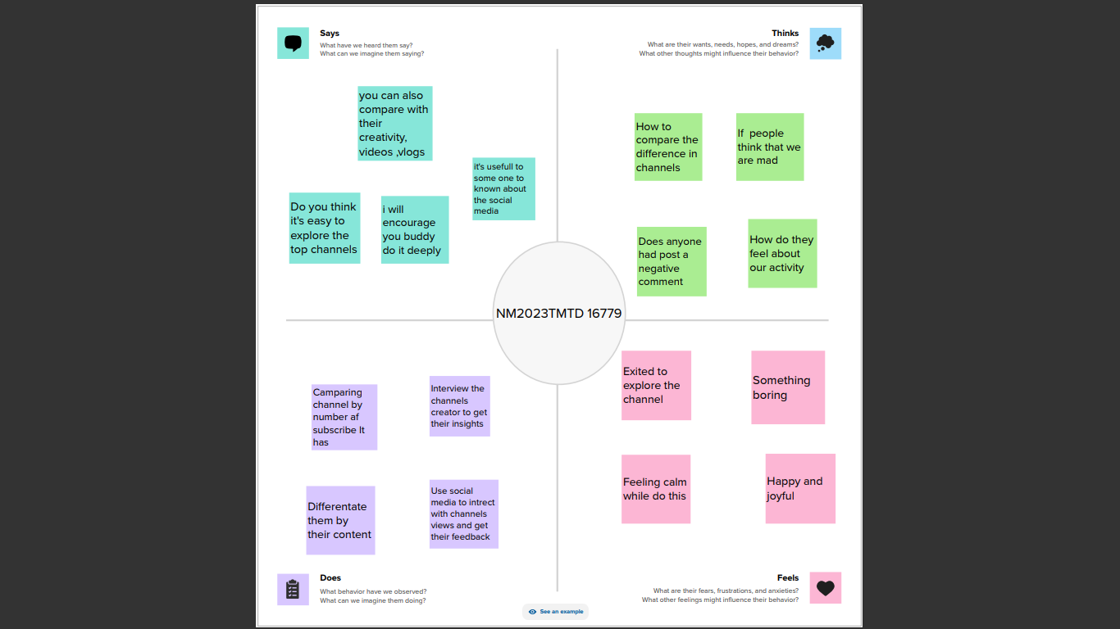

Brainstorming map:

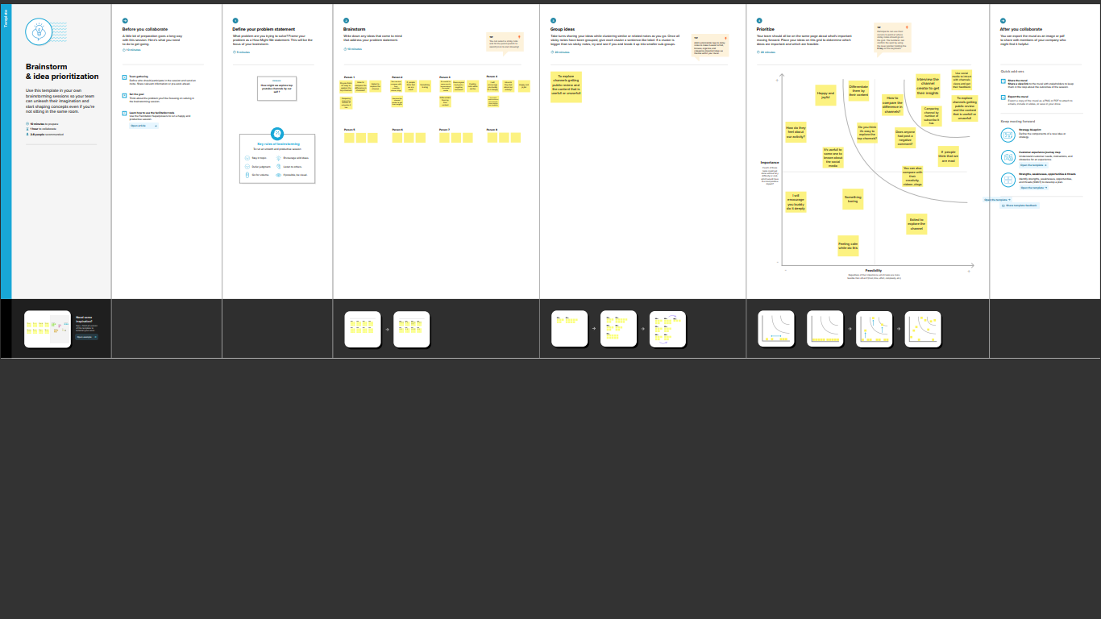

Result!

Final finding (output)of the project along with screenshot

Dashboard!

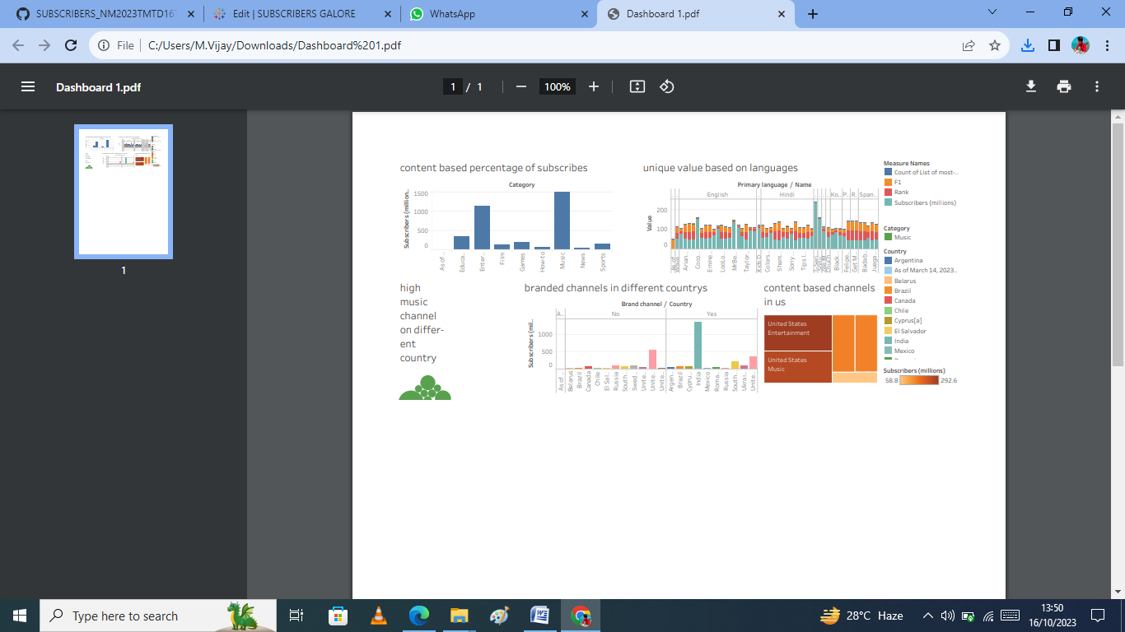

Story!

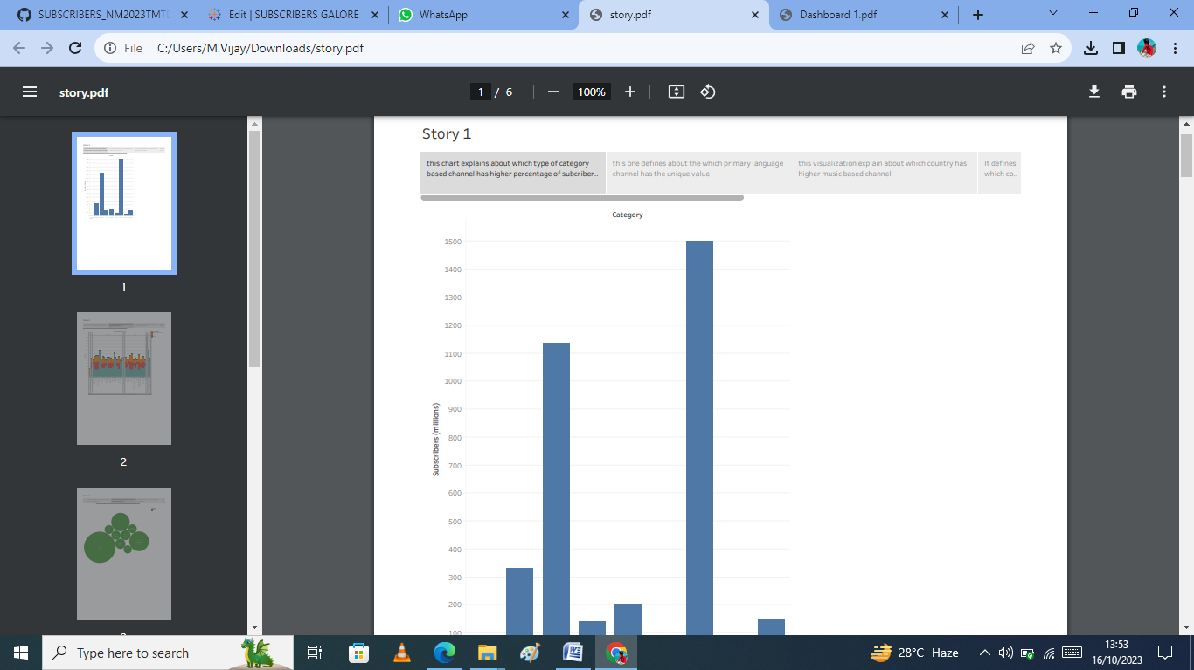

Video player types by youtube:

Design history of the video player used by Youtube .Note that Each layout generation might have gone through minor undocumented

Iterations, and that appearance may vary with embeddinParameters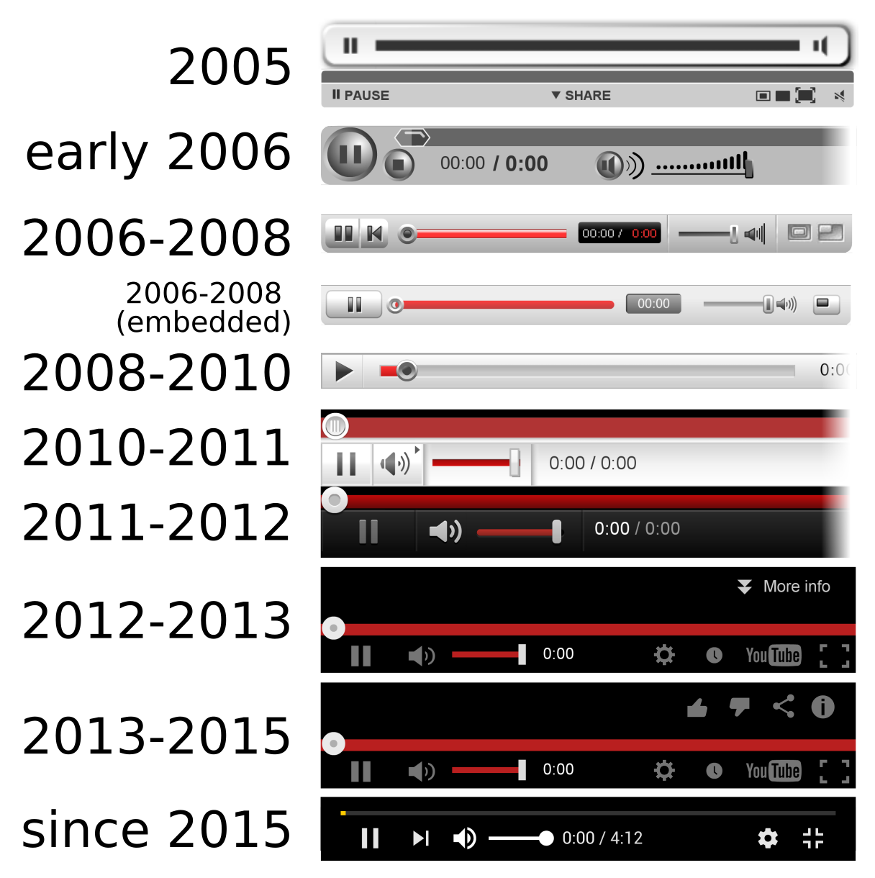.

Advantages:

* This project is help full to the new youtube users to identify which type of content has higher subscribers and views and helps to growth in the social media
* Its helpfull to understand which country has highest percentage of subscribers
* It also usefull to overview to which content based channels are presented in different countrys
* It helps to understand about social media and how much they earned and how they got promoted as a branded channels

Dis advantages:

* The main dis advantage about the project is it is difficult to collect and analyse the datas like number of subscribers , which Rank , which content based etc,…
* It’s difficult to orginate the channels in the rank wise and channel wise
* Bad comments and audio when you first begin publishing videos about this project and ppts.
* It requires lot of time and datas for collecting and analyzing the data

Conclusion:

In the spirite of exploratory data anylysis , we did not start from strict research question , but proceed mainly descriptively to provide a broad overview that can searve as a point of reference for researchers focusing on topic or user samples . our main goal was to ‘map’ youtube , not necessarily in visual terms , but with attention to various stratifying and sturucturing elements that , in part ,are established by youtube itself , for example when it comes to access to monetization through advertising or through the internal automated channel category system

Future scope!

Through this program, training modules in coding and robotics will also be provided. In addition, psychological counselors and medical physicians will provide guidance on the student's nutrition, physical fitness, and overall personality development.06-Aug-2023



THANK YOU